AWARENESS PROGRAMS
NSS unit of Aragonda Apollo College of Nursing, Aragonda
Mrs.Chithra .B - NSS Program officer.
Our NSS Unit is conducting various awareness programme that facilitated all public to gain knowledge and manage their health. Our NSS Volunteers are very enthusiastically organized and conducted various programs.
The following are the awareness programmes conducted by our NSS Unit.

Description | Date | No of participants including volunteers
School health program | 22.03.2018 | 350
Breastfeeding week | 01.08.2018 – 07.08.2018 | 200
Organ Donation | 11.08.2018 | 200
No Horn Day | 14.04.2018 | 150
Open Defecation free | 28.04.2018 | 350
Poshan Abhiyam | 12.09.2019 | 350

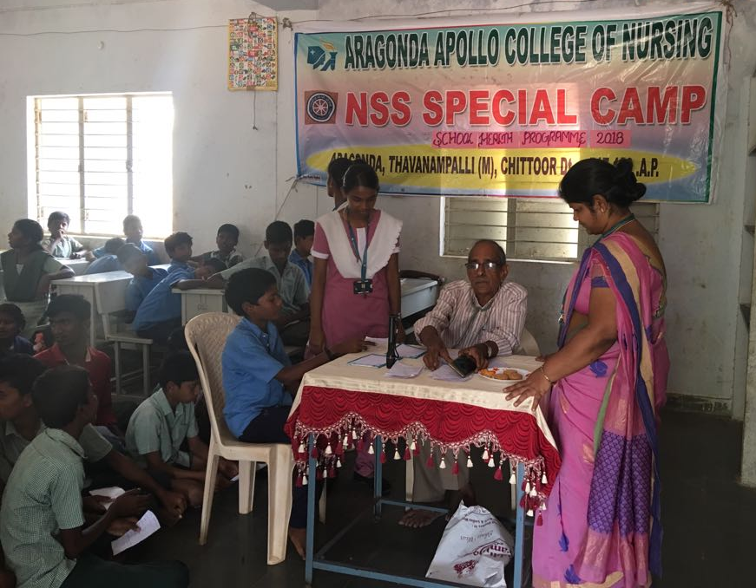

Fig 1: School Health Programme conducted at ZPHS School, Vengampalli NSS volunteer Ms.Thamaraiselvi, Mrs.Chithra .B, NSS Programme Officer, Dr.Azad

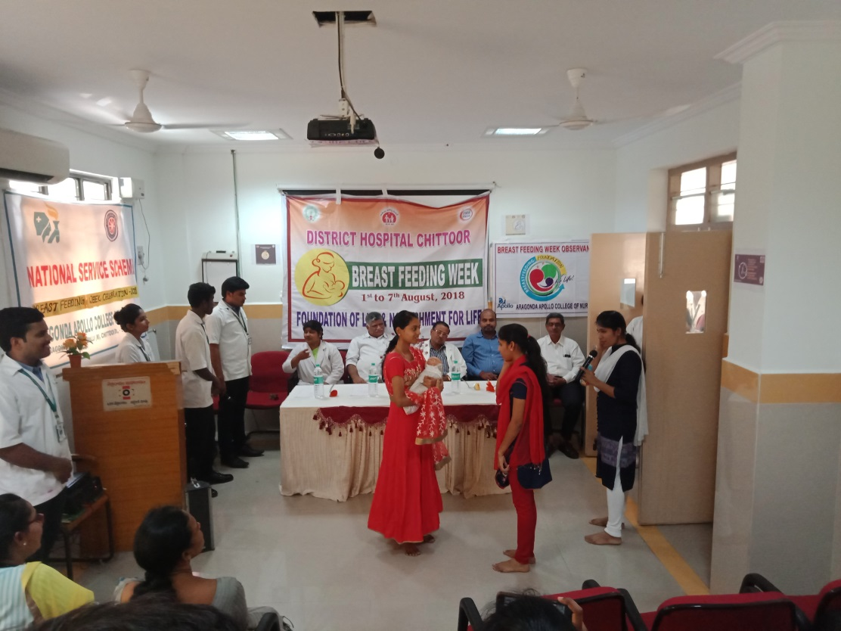
Fig-2.a: Students have demonstrated the types and importance of breastfeeding and techniques. NSS volunteers of Mr.Yasaswi, Ms.Neenu Mol, Ms.Vimala Rani & Ms.Anitha Sofiya.
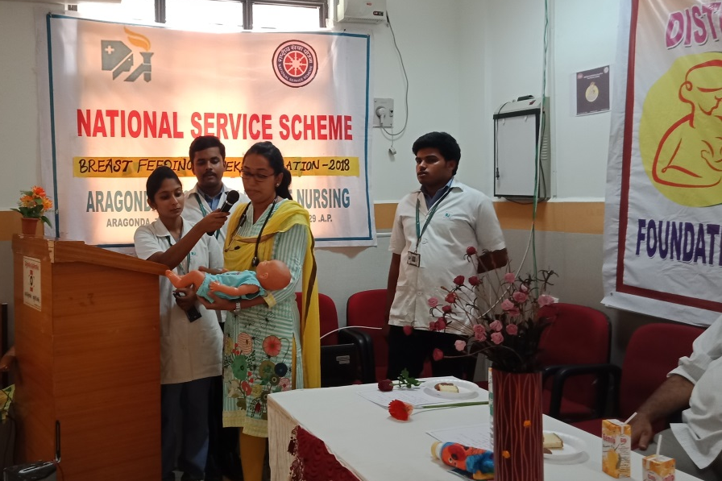
Fig 2.b: Dr.Anitha, addressed regarding Breast feeding and cleared the doubts of public.
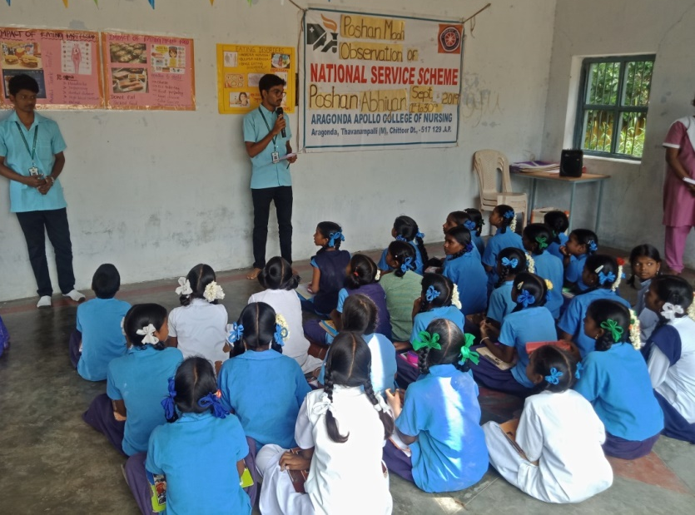
Fig-3 a : On the occasion of Poshan Abhiyaan Program, Mr.Puneeth, Mr.Pranay created awareness regarding impact of eating fast food.
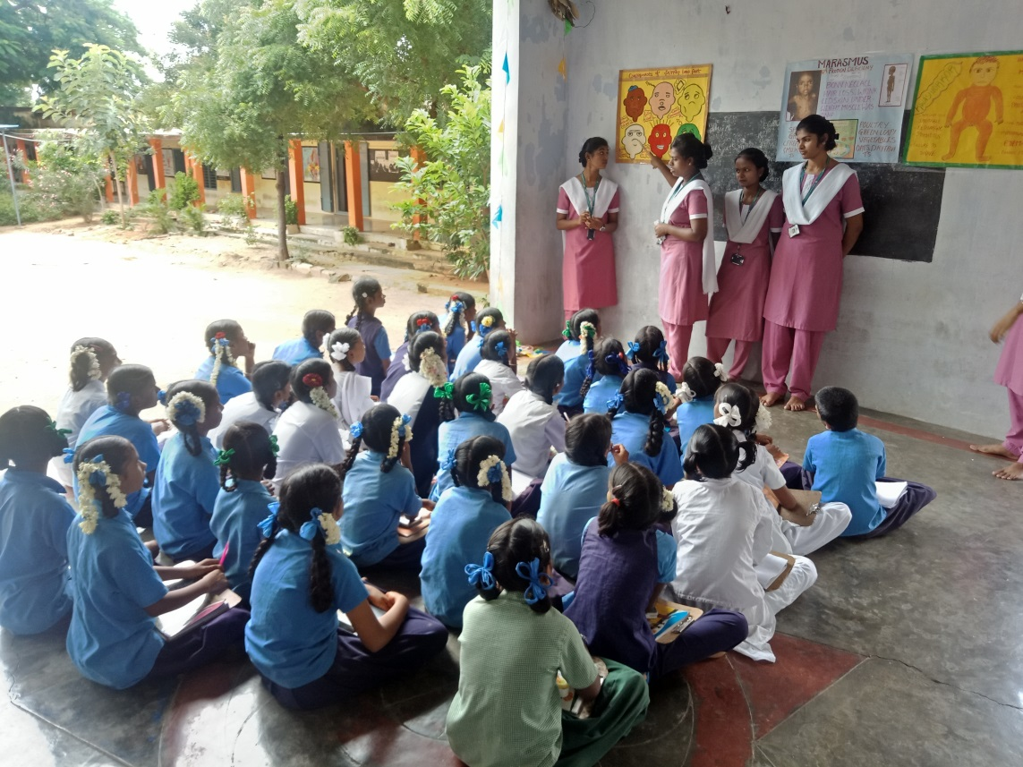
Fig-3 b : On the occasion of Poshan Abhiyaan Program, Ms.Ramya, Ms.Rohini created awareness regarding effects of skipping break fast, causes and management of PEM.
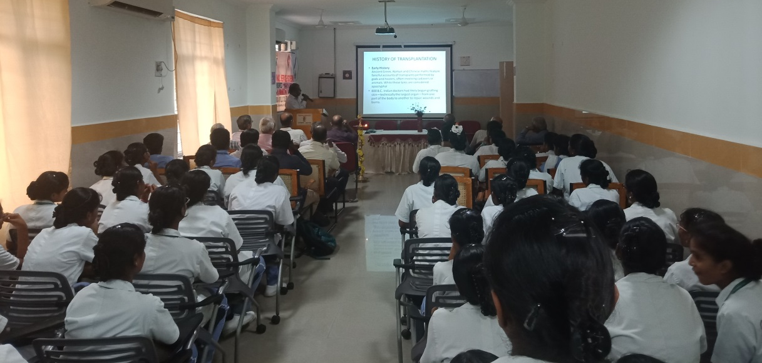

Fig-4 a: Prof. Dr.Daniel, gave a lectur on Organ donation and cleared the doubts regarding legal and ethical issues related to Organ donation.

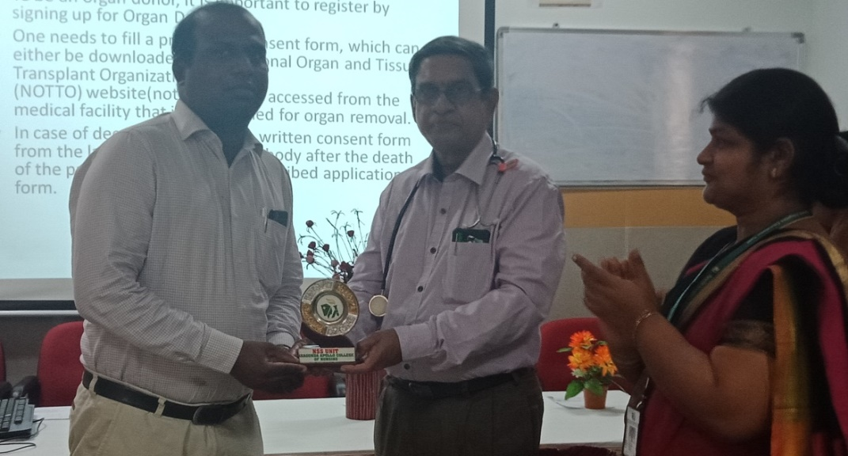
Fig-4 b: Dr.Uma Maheswar Rao, Medical Superintendent, Felicitated Dr.Daniel for his wonderful lecture on Organ donation held on 11.08.2018.
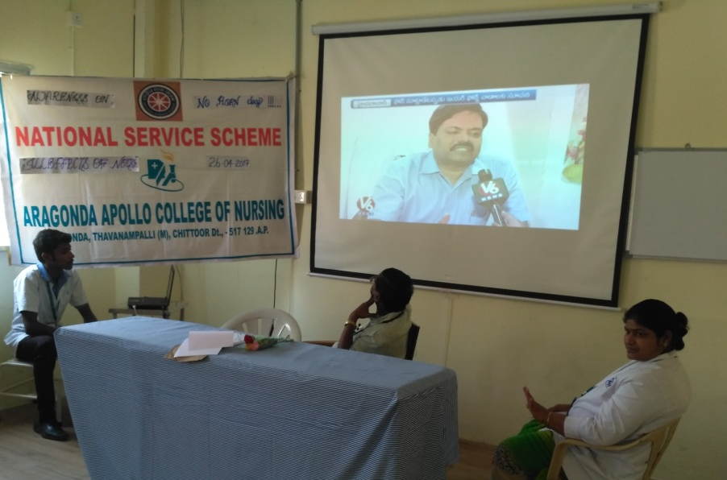
Fig-5 : Mr.Vasanth, NSS volunteer shown the Video on illeffects of noise Dr.Paul, HOD of ENT dept., addressed the group.
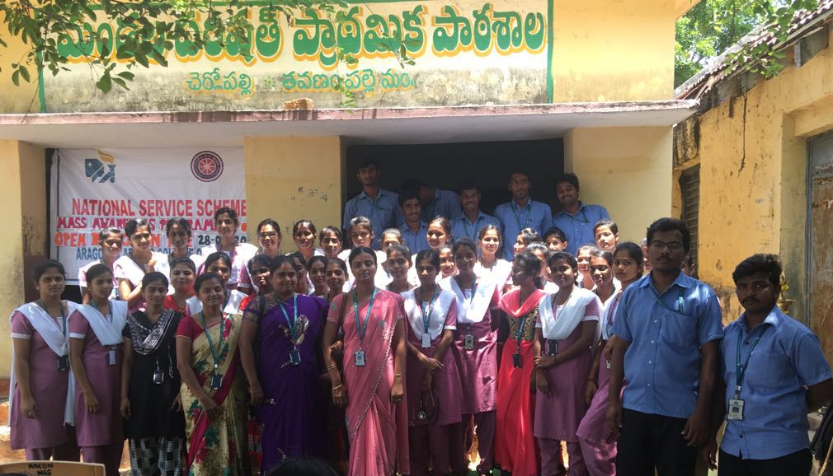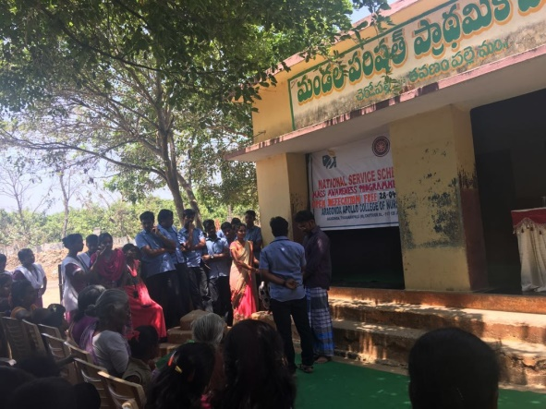
Fig-6 : Mass Awareness programme on Open defecation free and NSS Volunteers Mr.Ameen, Mr.Naveen, Ms.Reshma, Ms.Kripa Abraham, done a skit in Mass Awareness programme on Open defecation free on 28.04.2018.

